Welcome!
Date
Name
Spouse
Address
City
State Zip _________
Email

Please Contact By
❑ Card  Phone  Visit

Telephone Best Time to Call
Home ______________
Work ______________

Guest: First Time Second Time
Are you a church member: yes no
Church
City, State

Circle Appropriate Age/Grade Group(s)
Preschool: Ages: B-1 2-3 4-5
Children: Grades: K 1 2 3 4 5 6
Youth: Grades: 7 8 9 10 11 12
Adults: Ages:18-29 30s 40s 50s 60s+

How did you learn about our church?
Newspaper Friend Yellow Pages Mail
Other

I am a guest of:

New in the Community? Yes No
Names & ages of children at home

Weekly Service & Activity Schedule

Dec 4, 2016
9:45 a.m. Sunday School
11:00 a.m. Worship Service
12:00 p.m. Spirit Lifters SS Christmas Party
6:00 p.m. Evening Service

Week of Dec 4, 2016
Tuesday 6:30 pm……………..……….…..Ladies Craft Night
Wednesday 6:30 pm………………..…Meal/Bible Study
December
4-11……..………Week of Prayer for Lottie Moon Missions
8……………………….………..…………….Adult Fellowship
11………………………………..Church Christmas Program
16…………………….…………..Adult I SS Wrapping Party
18………………….…………..…………….Business Meeting
22……………………………………………..Adult Fellowship
31………………………………New Year’s Eve Watch Party

Join us for a Ladies Craft Night!!
Tuesday, Dec. 6 @ 6:30
We will be making Christmas cards for wounded warriors. The cost is $5/person to cover supplies and postage. Contact Brenda Williams if you want to attend so she can have the appropriate amount of supplies.
Church Christmas Program

Sunday Dec 11
6:00 pm

Not just for the kids this year! If you would like to participate in the program, there is a sign up sheet in the sanctuary. All are welcome to participate…individuals, groups, Sunday School classes…

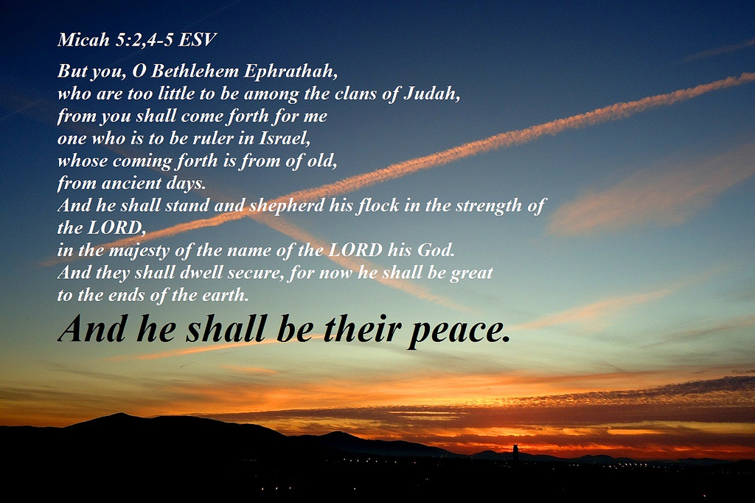

Knobbs Springs Baptist Church

December 4, 2016

Church Information:

KnobbsSpringsBC.com KnobbsSpringsBaptist@gmail.com

1662 CR 305, McDade, Texas 78650 512-273-2743

David Atwood, Pastor Cell 512-470-5098

Patti Radford, Office Manager Cell 512-968-7821

